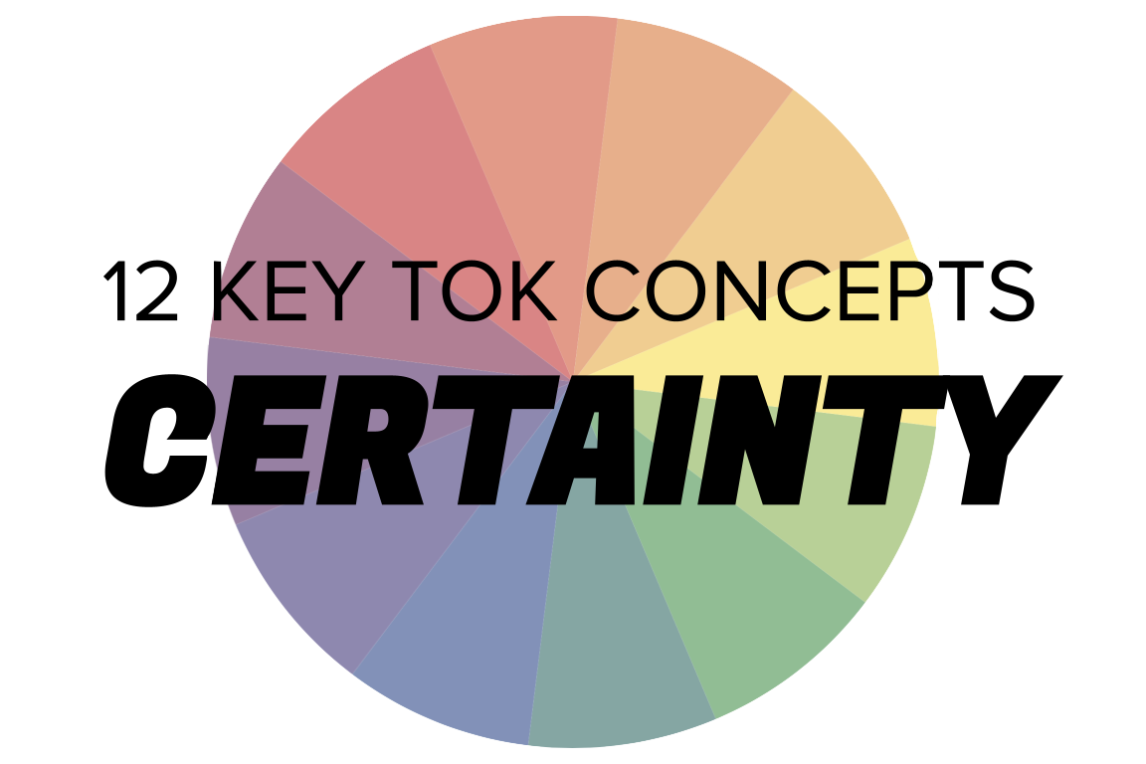 | CERTAINTY

Understanding the 12 key concepts
- The 12 key concepts are ones that have been identified as having a particular significant relationship to knowledge.
- Understanding, exploring, and using these concepts will help you to understand the way knowledge is produced and used, within the core and optional themes, and the areas of knowledge.
- You should also try to use the key concepts as extensively as possible in the two TOK assessment tasks.
Starting points for certainty  - How many online definitions can you find for ‘certainty’?  - Which one do you think best sums up this concept, and why?  - Which of the quotes below do you think provides us with the best insight into certainty? Are there any you disagree with?  - What are you certain of - and what makes you able to say that? | Quotes on certainty  - The only certainty is that nothing is certain. Pliny the Elder  - Dogmatism and skepticism are both, in a sense, absolute philosophies; one is certain of knowing, the other of not knowing. What philosophy should dissipate is certainty, whether of knowledge or ignorance. Bertrand Russell  - The quest for certainty blocks the search for meaning. Uncertainty is the very condition to impel man to unfold his powers. Erich Fromm  - Facts matter not at all. Perception is everything. It's certainty. Stephen Colbert  - Moral certainty can deafen people to any truth other than their own. Geraldine Brooks
Interlinking the key concepts  - To be certain of something, do we have to have evidence?  - Does certainty mean there can/should only be one interpretation?  - Does objectivity lead to certainty?  - Is it our responsibility only to make claims about things we are certain about?  - Is certainty the same as truth? | Relating certainty to the TOK course  - In which AOKs are we able to make the most and least certain claims about knowledge?  - Why does this variance exist?  - Does language allow us to be more certain about knowledge?  - Do our political and religious affiliations strengthen or undermine our certainty?  - Does technology help us to be certain about the world?
Relating certainty to the TOK exhibition  - IAP-8: Think about whether it is possible to be certain about the world  - IAP-25: Think about the comparative role of certainty in knowledge, belief, and opinion  - IAP-33: Think about our level of certainty changes over time, and also how our understanding of certainty has developed | Relating certainty to the Big Questions  - BQ1 What can you be certain about?  - BQ2 To what extent can we be certain about our values?  - BQ3 How do different forms of communication affect our ability to be certain about the world?  - BQ4 Does the existence of different perspectives prove that certainty is impossible?  - BQ5 Knowledge changes over time - so can we ever be certain about anything?  - BQ6 Do expert knowers aspire to, or avoid, being certain about the world?

Real-world contexts for certainty
The media sources below explicitly mention certainty (or uncertainty), and discuss this key concept in a real-world context. Use the find command (ie Command/Control+F) to locate the term in the article or transcript of the video, and you’ll see where it features. Check back regularly, as we update these media sources every month.
Big Question / knowledge framework | Description of media source and story and links to the course
BQ1 / Nature & scope | A Big Think article, discussing how quantum entanglement indicates that uncertainty is built into the structure of the Universe. Natural sciences, Mathematics, Technology  A New Humanist interview with John-Paul Stonard, who talks about his new book tracing the evolution of art from cave paintings to the contemporary era. The arts  An FT article, considering the difficulties of linking extreme weather to climate change, in the wake of the fires and floods that have recently affected countries around the world. Natural sciences, Technology, Mathematics, Politics, Knowledge & the knower  A BBC video, considering why the emergence of new facts about the world strengthens rather than undermines science. Natural sciences, human sciences
BQ4 / Perspectives | Two articles - from the Guardian and the Conversation - look at what we can learn about climate denial from the movie Don’t Look Up. Links to Natural sciences, The arts  A National Geographic article, which analyzes the different ways in which people assess the risks associated with the Covid pandemic. Knowledge & the knower, Natural sciences, Mathematics
BQ5 / Methods & tools | A Slate article, considering why computers on their own can’t generate random numbers, and the methods used to overcome this problem. Technology, Mathematics, Politics  A Big Think article, exploring the experiments that led to the discovery of three cognitive biases. Knowledge & the knower, Human sciences  A Guardian article which looks at the way mathematics is used to predict the future, particularly in terms of how Covid is likely to develop. Mathematics, Natural sciences, Human sciences  A Discover magazine article, exploring the upsurge in popularity of astrology. Knowledge & the knower, Natural sciences, Technology  A New York Times article, which looks at the “greatest breakthrough in the history of 20th century art”. The arts
BQ6 / Methods & tools | A Wired article, looking at how ordinary people are increasingly helping to gather data about the natural sciences. Natural sciences, Language  An Atlantic podcast, in which the Harvard psychologist Dr Ellen Langer asserts that being curious about the world is based on accepting there are gaps in your knowledge. Knowledge & the knower  A History Today article, looking at how history is a “never ending process”, and that it’s vital to have the ability to change your mind about your conclusions and judgements. History, Human sciences, Knowledge & the knower, Language  An Aeon essay, looking at the relationship between certainty and expertise about knowledge. Knowledge & the knower, human sciences  A Conversation article, which argues that the retractions, u-turns, and controversies over our knowledge of coronavirus shows that science is working as it should. Human sciences

